Histogram manipulation and basic segmentation

Objectives:
We will investigate the properties of the histogram and its various uses for image pre-processing, visualisation and segmentation.

During this session, you will learn & practice:
- More programming in matlab
- More examples of functions and scripts
- Histogram manipulation in matlab
- Simple segmentation techniques

Histogram manipulation:
As already seen in class, the histogram of an image is a simple way to see how the gray level (i.e. the information) is spread over the available range of grey levels. This in turn can be used to highlight problems during the acquisition (clipping due to over exposure, low contrast). The histogram can also be modified to make better use of the available range for further processing and display.

There is another way to see the histogram in the light of probability theory. An image can be seen as a random field (array) of pixels, each pixel being a random variable. Assuming these pixels follow the same statistical law, then the histogram can be interpreted as an estimator of the probability density function (pdf) of this law. This fact has been used for texture classification using local histograms for example (here, the texture are modelled locally by the histogram).

Matlab has several functions available to calculate and process histograms:
- imhist: Display the histogram of an image. Synthax: hist = imhist(ima,nb_boxes). imhist works with uint8 types images.

Simple segmentation using histograms: binarisation
In order to binarise an image, we have to find a suitable threshold to separate the image pixels into two classes of pixel value 0 and 1 (binary image). In general, you can fix the threshold by looking at the histogram (see imhist) . This technique is obviously not automated as it requires the user’s input. Moreover, the selection of the threshold is somehow very subjective.

In order to overcome this problem, several techniques have been proposed and we are going to investigate one. The technique, proposed by Otsu. consists in considering the histogram as the superposition of two clusters of grey levels belonging to 2 different classes. The threshold is calculated so that the mean square error between one point and its representative (cluster) is minimised. It is in fact a particular case of scalar quantification on N bits in the case of 1 bit. Let’s write 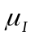and 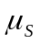the representatives of the two classes 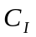and 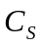. We want to minimize the following functional:
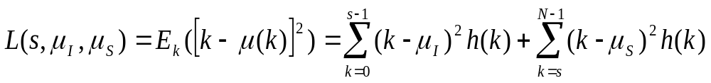
where N is the number of grey levels in the image, s the value of the threshold and h(k) is the value of the histogram (used as an estimate of the pdf of the grey level distribution).

Minimizing L with respect toand yields the following results

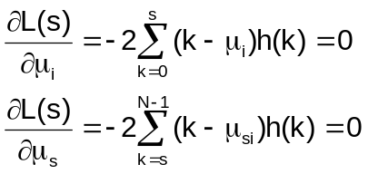
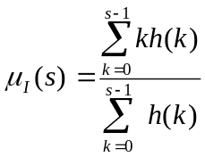 and 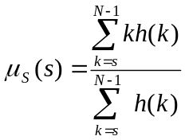
We can notice that and have a clear interpretation as the mean values of each class I and S. Reporting these expressions into L leads to a new functional to maximise which depends only on s:
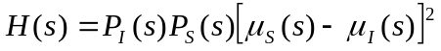
where
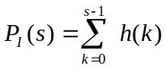and 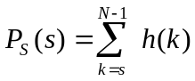

This expression has been obtained after some manipulations. As you can see, it is now only dependent on s. This expression can not be solve analytically but can be solved numerically.

